Resource
Working with Children Check
Compliance toolkit (Community Playgroup)
General information and summary only. Factsheet last updated January 2023. For more information see the WWC Act at www.legislation.wa.gov.au

Organisation
Document owner
Role
Date

This toolkit has been designed to be used by your organisation as an induction to your compliance requirements with the Working with Children (Screening) Act 2004.

This toolkit can also be used as an induction for individuals who are assigned responsibility for Working with Children (WWC) Checks within your organisation. Further information about your organisational responsibilities can be found in Factsheet PEN02 - Offences and penalties, employers, volunteer organisations and education providers.

This toolkit contains
- Compliance Checklist including links to factsheets, templates and supporting information.
- Attachments:
  - Attachment 1: WWC Check Registration Officer position description template
  - Attachment 2: Reference Check Questions
  - Attachment 3: Volunteer Declaration Form
  - Attachment 4: Flow chart- How do I know if someone needs a WWCC?
  - Attachment 5: Flow chart- Volunteer Recruitment Process
  - Attachment 6: Flow chart- Volunteer WWCC Management
  - Attachment 7: WWCC Record Keeping Spreadsheet:
  - Attachment 8: WWC Check Policy template
  - Attachment 9: WWC Check procedures template

Compliance checklist
1. Raise awareness
- WWC Checks added as an ongoing agenda item at committee/board meetings
Optional
- Attend a WWC Check Workshop, register at WWC Screening Unit Eventbrite

2. Organisation representatives
- Appoint a Committee Member who can verify applications and online renewals on behalf of the playgroup.
- Appoint a Committee Member who is the WWC Check point of contact within the playgroup to receive application outcomes and all correspondence.
- Appoint (or merge duties with an existing role) a WWC Check Registration Officer position (see Attachment 1: WWC Check Registration Officer position description template)

3. Volunteers who engage with child- related work
General information and summary only. Factsheet last updated June 2023. For more information see the WWC Act at www.legislation.wa.gov.au

- Complete referee checks for all potential volunteers engaging in child- related work. (suggested questions can be found in Attachment 2: Reference Check Questions)
- Complete the WWC Check record keeping spreadsheet, identifying volunteers who have a category of child-related work, have 'contact' with a child/children (and if any exemptions apply)
- If Volunteer requires a WWC Check, and does not currently have one. Volunteer to apply for WWC Check. WWC Check forms must be obtained from Australian Post outlets. A guide can be found here download. Playgroup volunteers fit under category 12 for child related work. Part 6 & 7 are completed by the playgroup (not Playgroup WA)
- Volunteer to complete Attachment 3: Volunteer Declaration form
Refer to:
- Attachment 3: Volunteer Declaration Form
- Attachment 4: Flow chart- How do I know if someone needs a WWCC?
- Attachment 5: Flow chart- Volunteer Recruitment Process
- Attachment 6: Flow chart- Volunteer WWCC Management
- Attachment 7: WWCC Record Keeping Spreadsheet
- Factsheet CRW02 – Exemptions, one off national event and national tour exemption.
- Factsheet CRW03 – Exemptions, the parent volunteer exemption.

7. Contractors and visitors
- Identify any contractors of, and visitors to, your playgroup, that have a category of child-related work, have 'contact' with a child/children and if any exemptions apply (as per step 6). For example, self-employed activity leaders, photographers and governing/parent/peak body representatives (e.g., Church Diocese).
- Visitor to complete Attachment 3: Volunteer Declaration form
- Update your WWC Check record keeping spreadsheet.
- Update contracts and communications with visitors to include the need for a valid WWC Check, where applicable.

8. Record keeping and monitoring
General information and summary only. Factsheet last updated June 2023. For more information see the WWC Act at www.legislation.wa.gov.au

General information and summary only. Last updated January 2023. For more information see the WWC Act at www.legislation.wa.gov.au

- Take a copy of
  - an individual’s WWC Card and check its validity or
  - an individual’s WWC application receipt and check its status.
- Ask volunteers who are exempt under the child volunteer exemptions or parent volunteer exemption to confirm that they are entitled to use the exemption by completing Attachment 3: Volunteer Declaration form
- Register as the employer/volunteer organisation of those who already have cards using the WWC Card holder registration page. There is no legal obligation for a person who is not in child-related work to have, or produce a WWC Card.
- Cease engaging individuals in 'child-related work’ if they do not have a valid WWC Card or have not applied for one (and provided a copy of the receipt).
- Update your record keeping spreadsheet.
- Store records in a secure location.
- Set reminders to re-check the validity of your employees and volunteers WWC Cards.
- Monitor WWC Card expiry dates and send relevant renewal reminders.
- Monitor that individual’s that are exempt remain exempt (e.g., if child volunteers turn 18 or become paid).
- Report any concerns to the WWC Screening Unit, including if you reasonably suspect an employee, volunteer or student has been charged with or convicted of an offence which makes it inappropriate for them to engage in child-related work.

Refer to:
- Factsheet CRW04: Exemptions, narrowing of access.
- Template ORG04: Working with Children Check, volunteer declaration.

9. Policies, procedures and compliance
General information and summary only. Factsheet last updated June 2023. For more information see the WWC Act at www.legislation.wa.gov.au

General information and summary only. Last updated January 2023. For more information see the WWC Act at www.legislation.wa.gov.au

- Adopt Playgroup WA Member Playgroup’s Child Protection Policy & Child Safe Code of Conduct.
- Develop your own WWC Check policy or integrate within existing child safeguarding policies.
Refer to:
- Attachment 8: WWC Check policy template.
- Attachment 9: WWC Check procedure template.
- National Principles of Child Safe Organisations.

Attachment 1: WWC Check Registration Officer position description template
Delete as appropriate
[Insert playgroup’s logo]
Working with Children Check Registration Officer

The Working with Children (WWC) Check Registration Officer is responsible for managing the playgroup’s WWC Check record keeping processes.

Accountability
The WWC Check Registration Officer is directly responsible to the [insert title] of [insert playgroup’s name].

Responsibilities and duties
- Adhere to the mission, vision, and values of the playgroup.
- Manage the WWC Check record keeping spreadsheet.
- Act as a representative of the playgroup’s on WWC Check application forms and online renewals.
- Check the validity of WWC Cards and status of application receipts.
- Advise the WWC Screening Unit of new workers who already hold WWC Cards.
- Cease engaging individuals in 'child-related work’ if they do not have a valid WWC Card or have not applied for one (and provided a copy of the receipt).
- Contact workers with expiring WWC Cards to remind them to renew.
- Ensure people who are accessing the child volunteer exemptions or parent volunteer exemption can legitimately access the exemption.
- Advise the committee of any WWC Check issues.
- Manage all data in accordance with the Privacy Act 1988.

Knowledge and skills required
- Good organisational skills.
- Ability to manage and maintain data.
- Computer literacy.
- Good communication skills.
This role may require a valid WWC Check if your playgroup deems the role to be in ‘child-related work’.

Time commitment
The estimated time commitment required as the WWC Check Registration Officer of [insert playgroup’s name] is [insert approximate hours] hours per week/month.

I have read and agree to the above position description.

Name: _______________________ Date: __________________

Signature: __________________________________________________

Last reviewed on: [insert date] Next review date: [insert date]
Reviewed by: [insert title of person] Approved by: [insert title of person]

Attachment 2: Reference Check Questions

Reference Check Questions for Volunteers working at Playgroup
To help playgroups establish a child-safe process for screening potential volunteers, below is a list of suggested reference check questions. Please select a few to use when contacting the volunteer referees.

1. Relationship & Context
- How do you know the applicant, and in what capacity?
- How long have you known or worked with them?
2. Suitability for Working with Children
- Have you seen the applicant interact with children? If yes, how would you describe their approach?
- Would you feel comfortable leaving a child in their care?
- Do they demonstrate respect, patience, and appropriate boundaries when working with children?
3. Character & Conduct
- How would you describe the applicant’s general behaviour and attitude?
- How do they handle stressful or challenging situations?
- Are they respectful and inclusive of people from different backgrounds?
4. Reliability & Teamwork
- Is the applicant dependable and responsible?
- Do they communicate well and follow instructions?
- How do they work as part of a team or group?
5. Concerns or Red Flags
- Are you aware of any concerns or issues regarding their behaviour around children?
- To your knowledge, has the applicant ever been involved in any situation that may pose a risk to children?
- Would you have any hesitation in recommending this person for a role working with children?
6. Final Question
- Is there anything else you think we should know before this person volunteers in a child-related setting?

Tips:
- Speak to at least two references — ideally one from a previous role involving children.
- Document responses clearly and confidentially.
- If any red flags arise, follow up or consider not proceeding.

Attachment 3: Volunteer Declaration form

Volunteer Declaration *
Organisation name
Role
Category of child-related work
Volunteer name
Date
- Do you already hold a Working with Children (WWC) Check?
Yes, detail below |  | No, move to question 2
Card number
Expiry date
Copy of card provided |  | Yes |  | Date provided
Organisation use only:
Date card validated
Date card holder registration completed
- Do you qualify for an exemption?
Yes, the child volunteer exemptions or the parent volunteer exemption,
move to question 3
Yes – other exemption, please detail below:

I do not qualify for an exemption, WWC application receipt number recorded below:
WWC application number
Organisation use only:
Date application status validated

- Are you entitled to the child volunteer exemptions or parent volunteer exemption?
Please note:
- access to the parent volunteer exemption varies for each category of child-related work
- the parent volunteer exemption is not available in all circumstances, including for an overnight camp, category 15
- individuals issued with a Negative Notice or Interim Negative Notice under the Working with Children (Screening) Act 2004 are not entitled to access the parent or child volunteer exemptions.
Yes, parent volunteer exemption. Please complete the declaration below
Yes, child volunteer exemptions. Please complete the declaration below
I declare that I am eligible to access the child volunteer exemptions or parent volunteer exemption.
Signed
Date
Please read the following carefully, and tick (✓) one of the boxes below:
1 | I declare that I DO NOT HAVE any convictions, circumstances or reasons, which might preclude my working with, or near, children
2. | I declare that I DO HAVE convictions, circumstances or reasons which might preclude my working with or near children. The nature of these convictions, circumstances or reasons is outlined below.  (Please attach a separate sheet of paper, if required)

Name:
Company: (if relevant)
Address:
Telephone:
Email:
Playgroup visiting:
Purpose of visit:
Signature:

I certify the accuracy of the above information.

Confidentiality: Please be assured that unless statutory obligations require otherwise, the information on the completed form will not be used without your consent for any purpose other than in relation to your entry onto the playgroup site.

Visiting multiple playgroup sites: If you visit many playgroups, then you must complete a separate Confidential Declaration form for each playgroup you visit. All playgroups are required to maintain records of all visitors at the playgroup site.

* This document is intended as a guide only to assist organisations in managing the volunteer exemption requirements under the Working with Children (Screening) Act 2004. It is not a legal requirement to complete this form.

Definitions of bold terms can be found in the Working with Children Check glossary at www.workingwithchildren.wa.gov.au.

Attachment 4: How do I know if someone needs a WWCC?
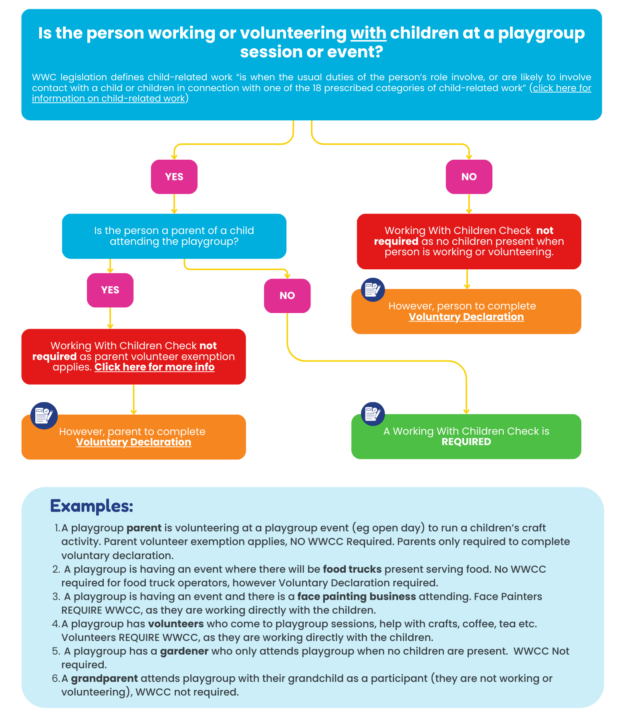

Attachment 5: Volunteer Recruitment Process
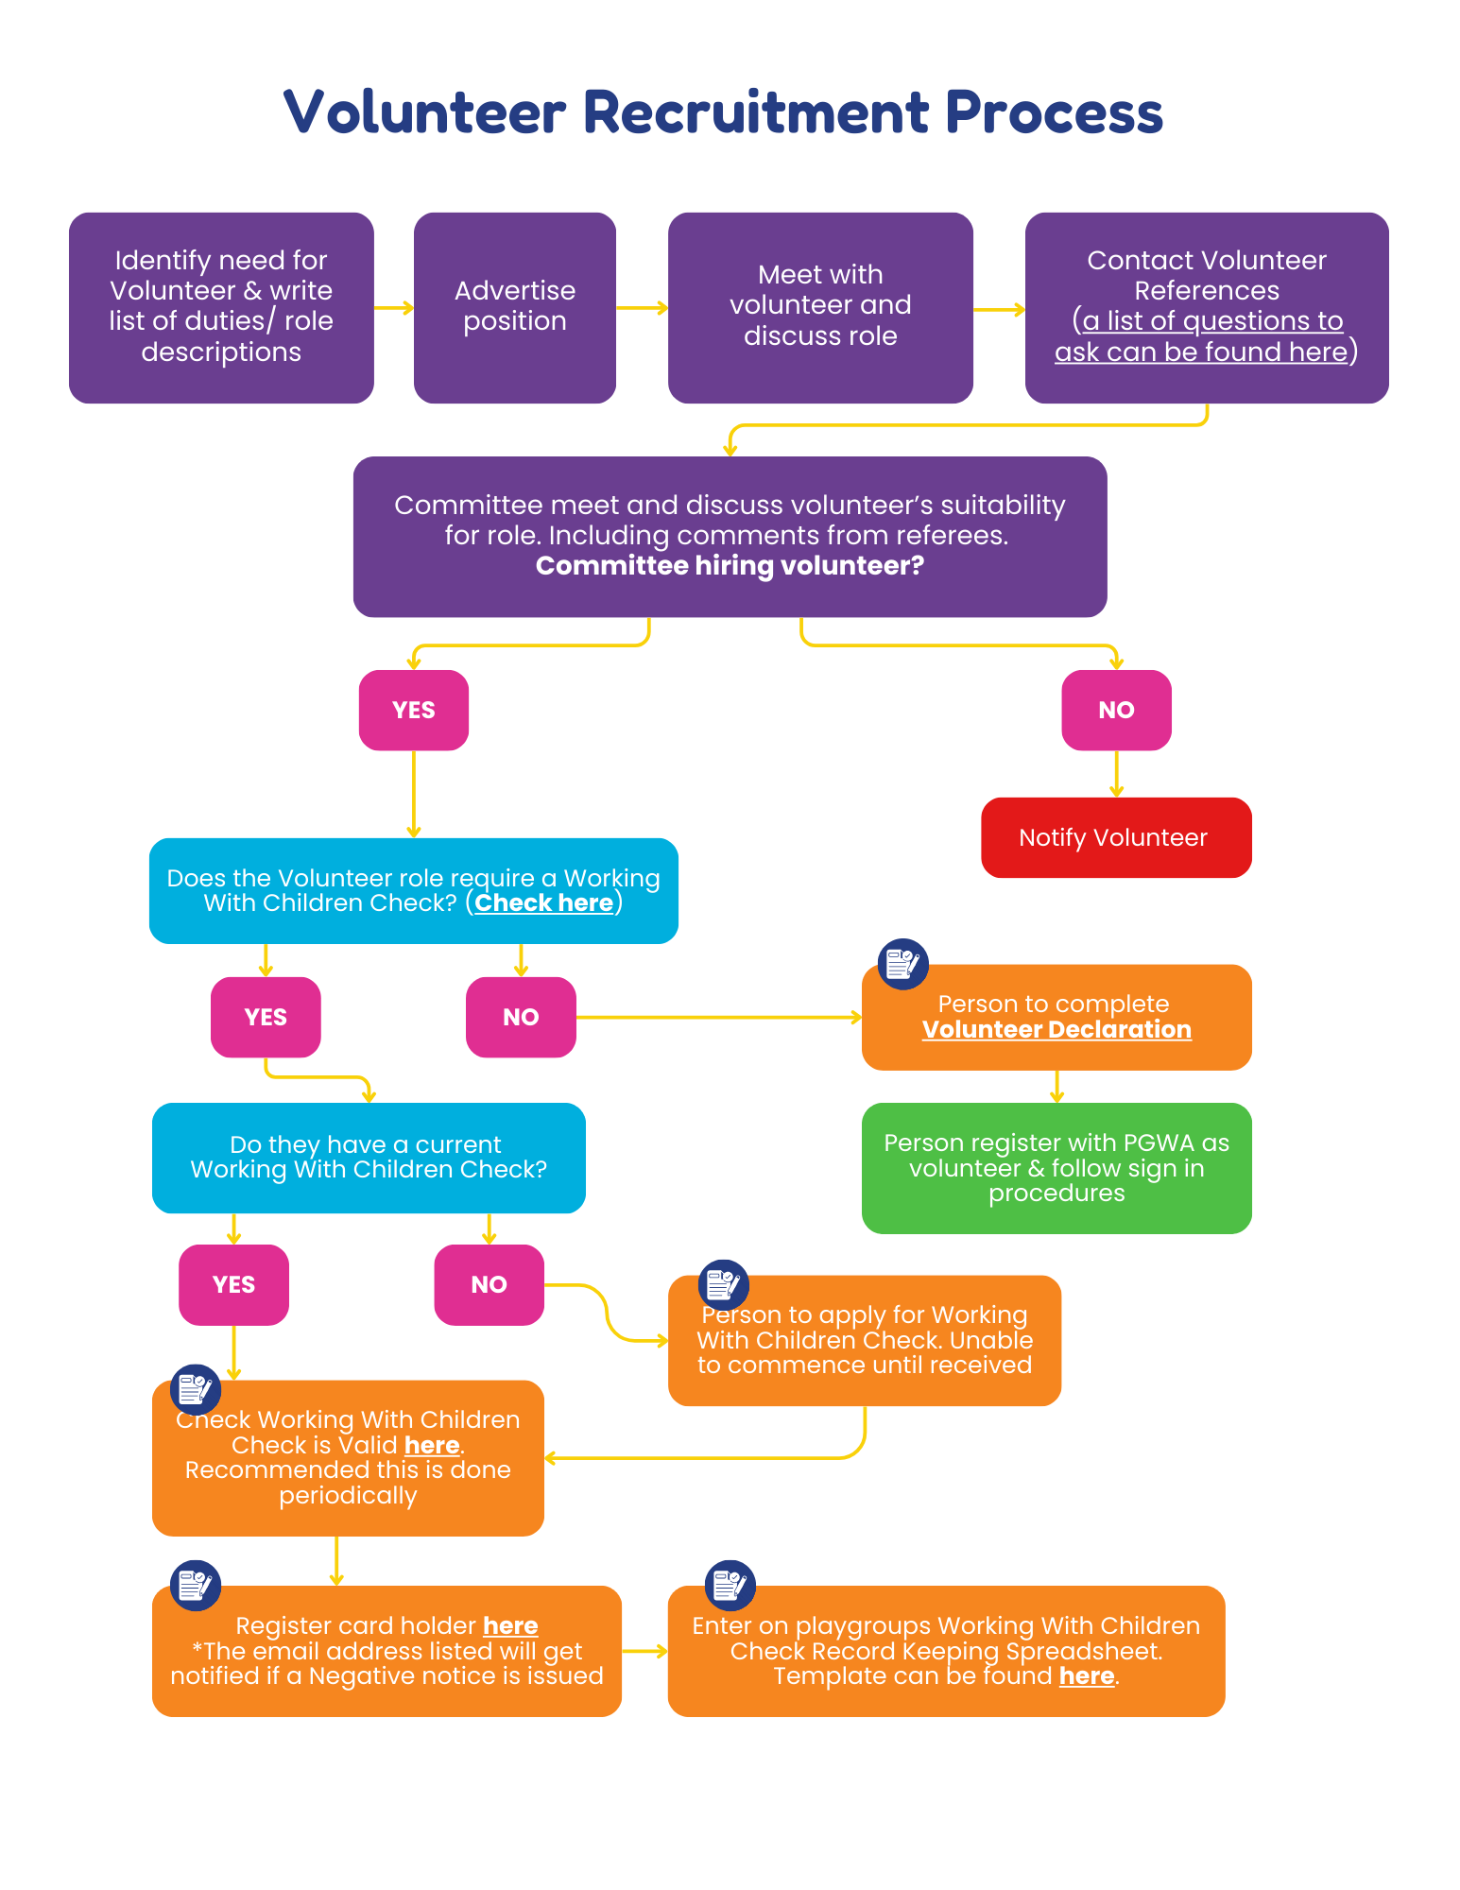

Attachment 6: Volunteer WWCC Management
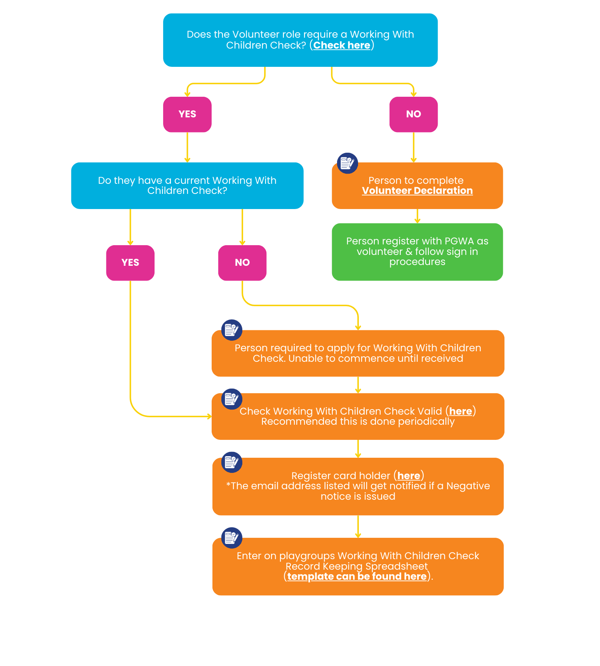
Attachment 7: WWCC Record Keeping Spreadsheet:

Spreadsheet template can be found here.

Attachment 8: WWC Check policy template
Delete as appropriate
[Insert playgroup’s logo]
Working with Children Check policy
Last reviewed on: [insert date] Next review date: [insert date]
Reviewed by: [insert title of person] Approved by: [insert title of person]

The Working with Children (WWC) Check is a compulsory screening strategy in Western
Australia and the Christmas and Cocos (Keeling) Islands for people who engage in certain
paid or unpaid work with children, described as “child-related work” under the Working with
Children (Screening) Act 2004 (the WWC Act).

The purpose of this policy is to outline the playgroups obligations, responsibilities and expectations under the WWC Act.

This policy is to be read in-conjunction with the following documents and legislation:
- [Insert any relevant playgroup’s, State Association and National Association policies].
- National Principles for Child Safe Organisations.
- Working with Children (Screening) Act 2004.
- Working with Children (Screening) Regulations 2005.
- Reportable Conduct Scheme (Ombudsman WA).

Definitions
- Child means a person who is under the age of 18 years.
- Contact means any form of physical contact, any form of oral communication, whether face to face, by telephone or otherwise and any form of electronic communication. However, it does not include contact in the normal course of duties between an employer and an employee or between employees of the same employer.
- Interim Negative Notice means that the WWC Screening Unit has received information relevant to the immediate safety of children, and the person is prohibited from engaging in child-related work during the assessment or re-assessment until a final decision is made.
- Member means an individual who is a member of [insert playgroup’s name].
- Negative Notice means that the WWC Screening Unit’s assessment or re-assessment of a person’s eligibility to hold a WWC Card indicates an unacceptable risk to children, and they are prohibited from engaging in child-related work.
- Representative means the person(s) who have who has been given permission by [insert playgroup’s name] to sign WWC Check application forms and confirm online renewals on [insert playgroup’s name]’s behalf.
- Voluntary work is where an individual receives no financial reward or remuneration. A person who receives payments that just cover the costs of carrying out their child-related work is considered to receive “no financial reward” and is considered to be a volunteer by the WWC Screening Unit.
- WWC Act means the Working with Children (Screening) Act 2004.
- WWC Check means the Working with Children Check.
- WWC Card means a Working with Children Card or Assessment Notice.

Background
Under the WWC Act, people whose usual duties of work involve (or are likely to involve) contact with a child in connection with one or more categories of child-related work and where no exemptions apply, are required to have a WWC Check. [Insert playgroup’s name] will take all reasonable steps to identify who within the playgroup is in child-related work and if a WWC Check is required.

Obligations
[Insert playgroup’s name] has an obligation to comply with the WWC Act. When seeking nominations or expressions of interest for appointments (paid or voluntary) [insert playgroup’s name] will provide the applicant with information regarding the screening
process and the specific criteria for the position. [Insert playgroup’s name] will keep and maintain accurate records of all individuals with a current WWC Check and periodically check the validity of a WWC Check, for both new and existing employees/contractors/volunteers/visitors.

Employees/contractors/volunteers/visitors have a responsibility to comply with all requirements to the satisfaction of [insert playgroup’s name]. If individual circumstances change and contravene this policy and the WWC Act, it is the responsibility of the individual to notify [insert playgroup’s name].

Where an employee/contractor/volunteer/visitor engaging in child-related work refuses to obtain or renew a WWC Check, [insert playgroup’s name] will remove them from child-related work. Employees/contractors/volunteers/visitors who are exempt from obtaining a WWC Check under the child volunteer exemption or parent volunteer exemption must confirm that they are eligible to do so.

If the playgroup receives notification of a Negative Notice or Interim Negative Notice, the playgroup will cease to engage the individual in child-related work.

Confidentiality
It is critical that confidentiality is maintained at all times. Information obtained during the screening process will not be provided to any person who is not authorised to access such information. The playgroup will ensure that only organisation representatives will sign WWC Check applications and confirm online renewals and that the President will be nominated as the representative to receive the outcomes.

Interstate travel
[Insert playgroup’s name] employees/contractors/volunteers travelling with children to another state or territory will comply with the WWC Act and the screening requirements of that particular state or territory.

Policy application
- This policy applies to all [insert playgroup’s name] employees/contractors/volunteers/visitors and all other people or organisations which by agreement or otherwise, are bound to comply with this policy.
- This policy applies to behaviour occurring during the course of [insert playgroup’s name] usual business/activities/events.

Responsibilities
[Insert playgroup’s name] role and contribution in making this policy work is to take all reasonable steps necessary to ensure that everyone in the playgroup knows:
- what the WWC Check is
- what this policy represents and their roles and responsibilities.

This will be achieved by:
- placing the safety and welfare of children above other considerations
- raising awareness of the WWC Check and the playgroup’s compliance requirements throughout the playgroup
- appointing a WWC Check Registration Officer
- identifying the categories of child-related work that the playgroup employees/contractors/volunteers/visitors engage in
- keeping adequate records that demonstrate our compliance with the WWC Act
- checking, recording and validating WWC Cards of all new employees/contractors/volunteers/visitors
- notifying the WWC Screening Unit of new employees/volunteers who already have a WWC Card from a previous employer/volunteer organisation
- periodically checking and recording that all current employees/contractors/volunteers WWC Cards are valid, current and have not been cancelled
- having a process to ensure employees/volunteers engaging in child-related work renew their WWC Cards every three years, before their WWC Cards expire
- having a process in place to ensure that any employee/volunteer issued with an Interim Negative Notice or Negative Notice does not engage in child-related work
- having a process in place for child and parent volunteers to declare that they do not have a current Interim Negative Notice or Negative Notice and that they are eligible to access the child volunteer exemptions or parent volunteer exemption
- educating employees/contractors/volunteers/visitors on this policy and procedures identifying that they will be required to comply with this policy and outlining the possible consequences associated with breaches of this policy
- providing opportunities for the sharing of best practice and feedback
- reporting any concerns to the state association, WA Police and WWC Screening Unit as appropriate
- reviewing this policy and updating as required every 12 months.

Policy breaches
[Insert playgroup’s name] will take all breaches of the policy seriously and will ensure they are dealt with promptly, sensitively and confidentially. Disciplinary action may be taken against a person who is found in breach of this policy, in accordance with the [insert playgroup’s name] Complaints management procedure.

Attachment 9: WWC Check procedure template

[Insert playgroup’s logo]
Working with Children Check procedure
Last reviewed on: [insert date] Next review date: [insert date]
Reviewed by: [insert title of person] Approved by: [insert title of person]

[Insert playgroup’s name] aims to continually review the Working with Children (WWC) Check procedure to ensure the documented processes comply with current legislative requirements.

Positions in child-related work
[Insert playgroup’s name] will:
- identify all the activities undertaken within the playgroup and the corresponding category of child-related work listed within the WWC Act, where applicable
- identify all positions within the playgroup and if the duties involve, or are likely to involve, contact with a child
- review and develop position/role descriptions identifying the screening requirements where applicable
- ensure that all adverts and notices identify the screening requirements.

Working with Children Check screening
[Insert playgroup’s name] will identify those that require a WWC Check by:
- identifying individuals undertaking positions/roles in child-related work and determining if an exemption applies
- obtaining a statement from child and parent volunteers confirming their eligibility to access the child volunteer exemptions or parent volunteer exemption
- obtaining copies of WWC Cards by:
  - acting as a representative by signing new WWC Check applications or confirming online WWC Card renewals and
    - nominating the President as the representative to receive application and renewal outcomes or
  - obtaining a hard copy of current WWC Cards or application receipts and

    - validating the card details or checking the application status and
    - notifying the WWC Screening Unit that the individual has commenced employment/voluntary activity with the playgroup via the Card Holder Registration Form, where applicable.

Record keeping
The WWC Check Registration Officer will maintain a register of those engaged in child-related work, which will be checked [insert frequency] to:
- check the validity of WWC Cards of employees/volunteers and current contractors/visitors
- notify the WWC Check Screening Unit of new and former employees/volunteers using the WWC Card holder registration form
- set reminders for WWC Cards that are about to expire.

The register will be stored in a safe and secure location as determined by the committee.

Managing a Negative Notice or Interim Negative Notice
On receipt of notification that an individual has received a Negative Notice or Interim Negative Notice, the playgroup’s President/representative will:
- inform the individual that they are prohibited from child-related work within the playgroup
- liaise with the committee and/or state association to determine if the individual can undertake any other role within the playgroup that does not pose a risk to children and report any outcomes to the individual concerned
- inform the individual of any restrictions placed on, or termination of, their involvement with the playgroup (as determined by the committee and/or state association)
- inform relevant playgroup employees/contractors/volunteers/visitors that the individual is no longer undertaking that role, maintaining confidentiality at all times
- share information with other playgroup employees/volunteers and other organisations on a need-to-know basis, maintaining confidentiality at all times
- document all actions and processes undertaken
- liaise with the WWC Screening Unit where required
- manage any media attention and requests
- monitor that the individual is not undertaking child-related work with the playgroup’s on an ongoing basis.

Reporting
[Insert playgroup’s name] will:
- report concerns to the state association, WA Police and WWC Screening Unit as required
- notify the WWC Screening Unit if [insert playgroup’s name] believes that an individual is still undertaking child-related work following the issuing of an Interim Negative Notice or Negative Notice
- notify the WWC Screening Unit in writing if [insert playgroup’s name] reasonably suspects an employee/volunteer has been charged with or convicted of an offence which makes it inappropriate for them to continue to carry out child-related work.

Raising awareness / education
[Insert playgroup’s name] will:
- promote relevant training to key employees/contractors/volunteers within the playgroup
- promote the WWC Check on the playgroup’s website/social media pages/newsletters
- make the WWC Check policy available to staff and volunteers in the playgroup’s handbooks and externally available at [playgroup’s website]
- ensure that this policy is included in the handover / induction for key employees/contractors/volunteers of the playgroup
- provide opportunities for the sharing of concerns and best practice through meetings and forums
- seek feedback from employees/contractors/volunteers/visitors when reviewing the WWC Check policy annually.

