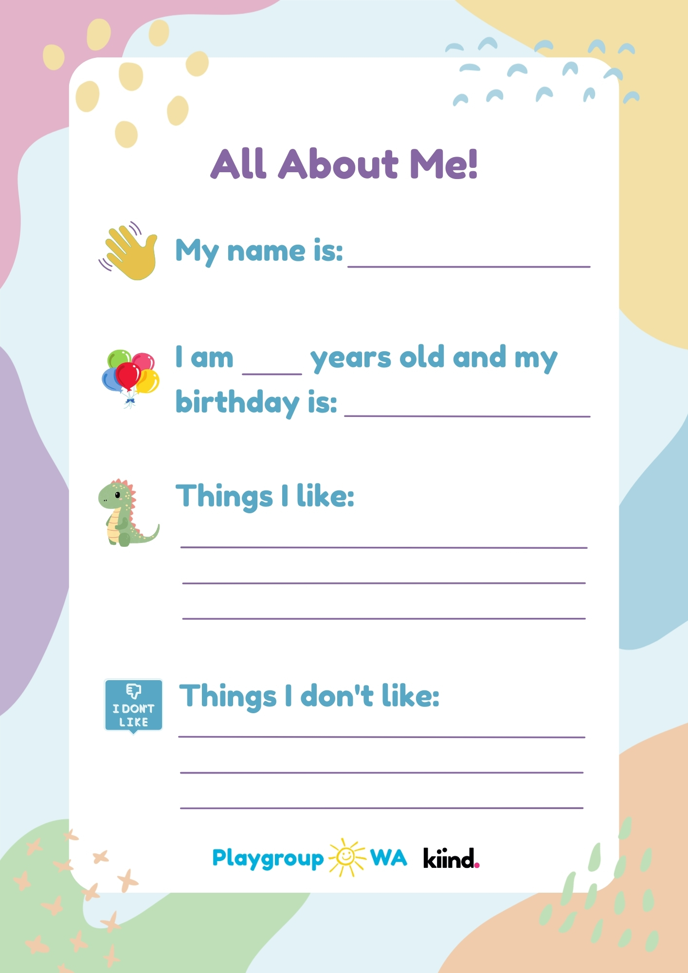
Insert Text
Insert Text
Insert Text
Insert Text
Insert Text
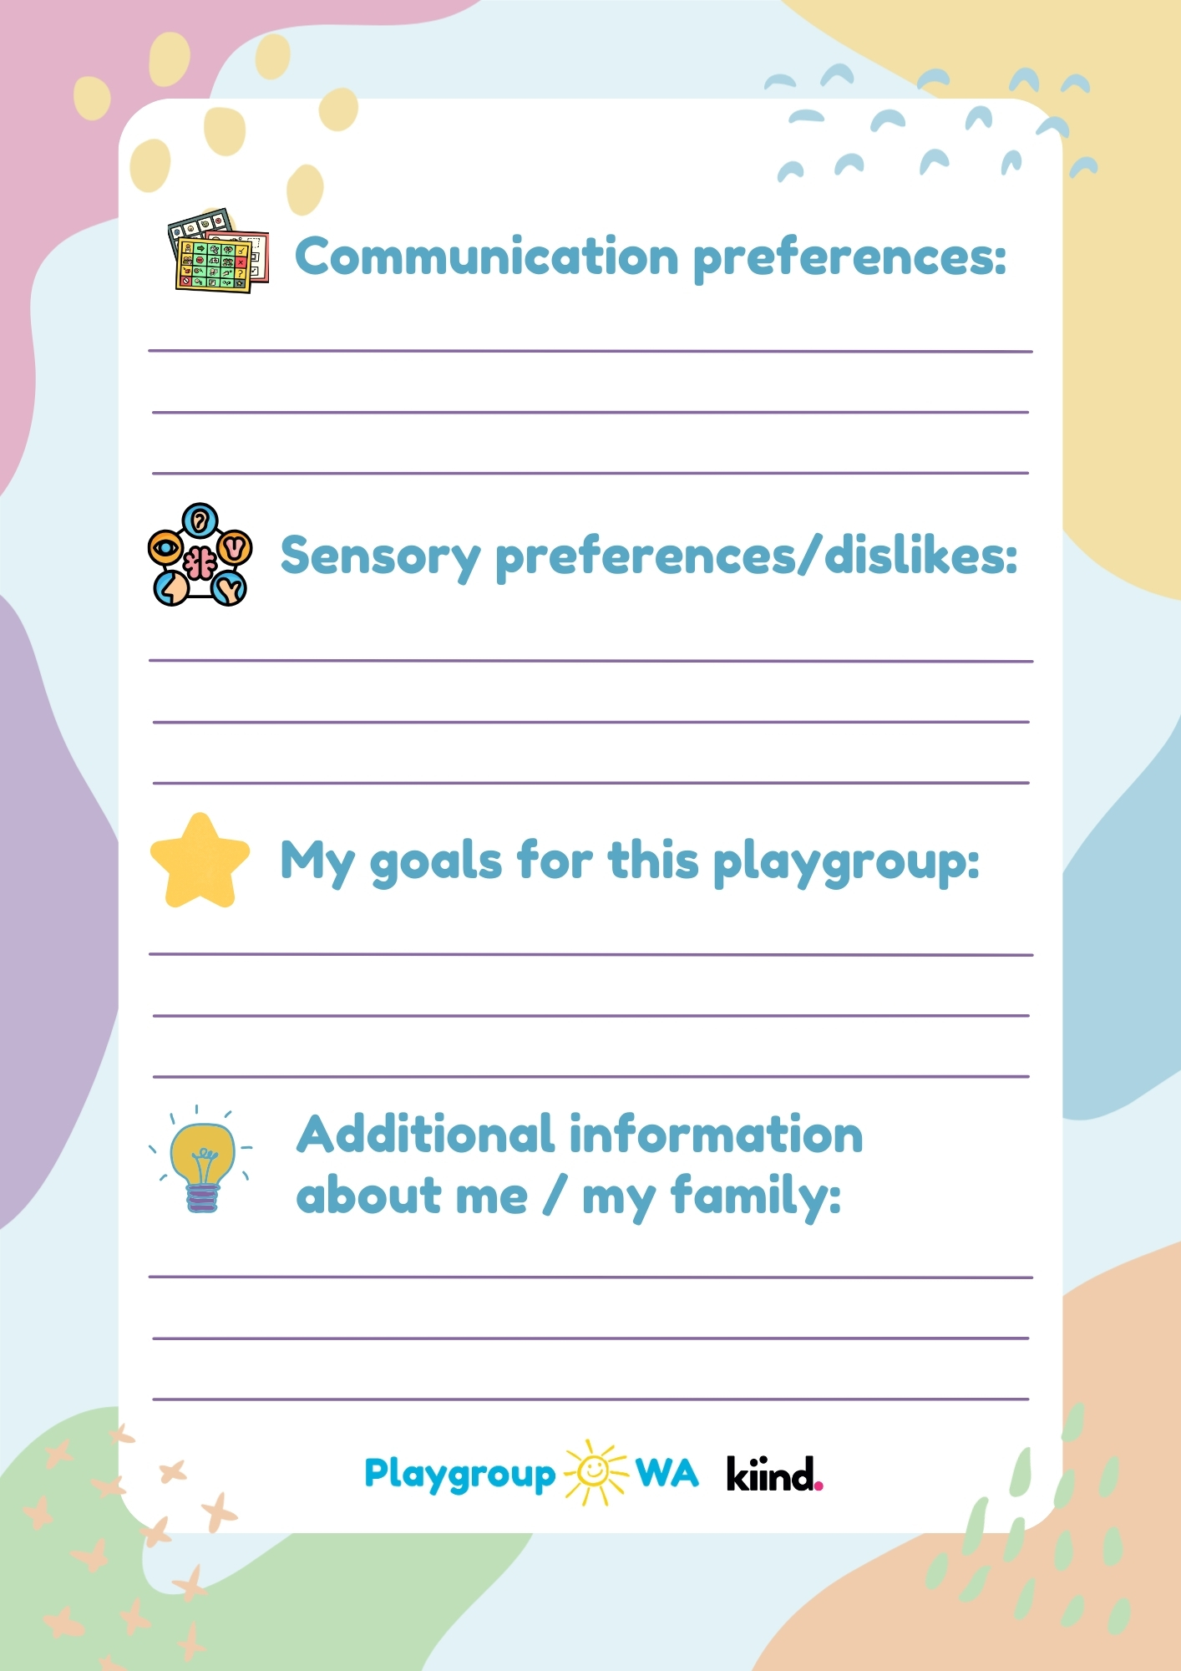
Insert Text
Insert Text
Insert Text
Insert Text

